The Commonwealth of Massachusetts
Executive Office of Health and Human Services
Department of Public Health
Bureau of Infectious Disease and Laboratory Sciences
305 South Street, Jamaica Plain, MA 02130
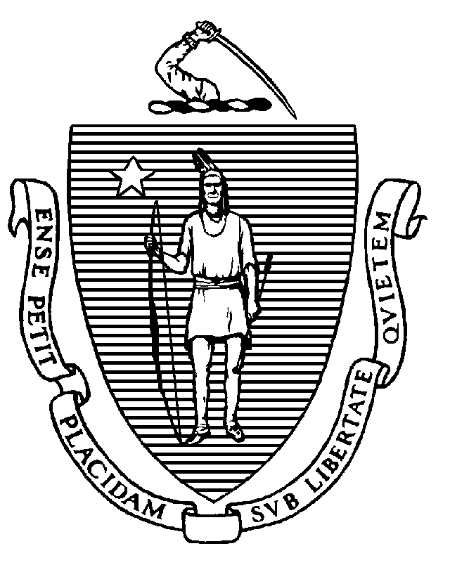

KATHLEEN E. WALSH
Secretary
ROBERT GOLDSTEIN, MD, PhD Commissioner

Tel: 617-624-6000
www.mass.gov/dph

MAURA T. HEALEY
Governor
KIMBERLEY DRISCOLL
Lieutenant Governor

To: Camp Directors

From: Pejman Talebian, MA, MPH, Director, Immunization Division

Date: March 22 2024

Subject: Required Immunizations for Children Attending Camp and Camp Staff

Vaccination is critically important to control the spread of vaccine-preventable diseases. Since the COVID-19 public health emergency ended, there has been a resurgence of many vaccine-preventable diseases. In 2024, measles outbreaks are occurring worldwide including in multiple European countries. In the US, as of mid-March, there have already been as many confirmed cases of measles (58) as there were in all of 2023, impacting 17 different jurisdictions. A single case of measles can result in hundreds of exposures, with a 21-day quarantine required of those who do not have evidence of immunity to measles and who cannot be vaccinated within three days of exposure. The way to avoid this situation, which can bring a summer camp to a halt, is to ensure that children attending camp and camp staff have evidence of immunity to measles.

Required Vaccines:
Minimum Standards for Recreational Camps for Children, 105 CMR 430.152, has been updated. Immunization requirements for children attending camp follow the Massachusetts school immunization requirements, as outlined in the Massachusetts School Immunization Requirements table, which reflects the newest requirement: meningococcal vaccine (MenACWY) for students entering grades 7 and 11 (on or after the 16th birthday, in the latter case; see the tables that follow for further details). Children should meet the immunization requirements for the grade they will enter in the school year following their camp session. Children attending camp who are not yet school-aged should follow the Childcare/Preschool immunization requirements included in the School Immunization Requirements table.

Campers, staff, and volunteers 18 years of age and older should follow the immunizations outlined in the document Adult Occupational Immunizations.

The following pages includes portions of the Massachusetts School Immunization Requirements table and Adult Occupational Immunizations table relevant to camps.

If you have any questions about vaccines, immunization recommendations, or suspect or confirmed disease cases, please contact the MDPH Immunization Program at ImmAssessmentUnit@mass.gov. Address questions about enforcement with your legal counsel; enforcement of requirements is at the local level.

See the following page for Grades Kindergarten–6, and Grades 7–12

Requirements apply to all students, including individuals from other countries attending or visiting classes or educational programs as part of an academic visitation or exchange program. Requirements apply to all students in every grade, even if they are over 18 years of age.

Childcare/Preschool¶†
Attendees <2 years should be immunized for their age according to the ACIP Recommended Immunization Schedule. Requirements listed in the table below apply to all attendees ≥2 years. These requirements also apply to children in preschool classes called K0 or K1.

Hib | 1–4 doses; number of doses is determined by vaccine product and age the series begins
DTaP | 4 doses
Polio | 3 doses
Hepatitis B | 3 doses; laboratory evidence of immunity acceptable
MMR | 1 dose; must be given on or after the 1st birthday; laboratory evidence of immunity acceptable
Varicella | 1 dose; must be given on or after the 1st birthday; a reliable history of chickenpox* or laboratory evidence of immunity acceptable

Grades Kindergarten–6
In ungraded classrooms, Kindergarten requirements apply to all students ≥5 years.
DTaP/Tdap | 5 doses; 4 doses are acceptable if the fourth dose is given on or after the 4th birthday; DT is only acceptable with a letter stating a medical contraindication to DTaP
Polio | 4 doses; fourth dose must be given on or after the 4th birthday and ≥6 months after the previous dose or a fifth dose is required; 3 doses are acceptable if the third dose is given on or after the 4th birthday and ≥6 months after the previous dose
Hepatitis B | 3 doses; laboratory evidence of immunity acceptable
MMR | 2 doses; first dose must be given on or after the 1st birthday, and second dose must be given ≥28 days after first dose; laboratory evidence of immunity acceptable
Varicella | 2 doses; first dose must be given on or after the 1st birthday and second dose must be given ≥28 days after first dose; a reliable history of chickenpox* or laboratory evidence of immunity acceptable

Grades 7–12
In ungraded classrooms, Grade 7 requirements apply to all students ≥12 years.
Tdap | 1 dose; and history of DTaP primary series or age-appropriate catch-up vaccination; Tdap given at ≥7 years may be counted, but a dose at age 11–12 is recommended if Tdap was given earlier as part of a catch-up schedule; Td or Tdap should be given if it has been ≥10 years since last Tdap
Polio | 4 doses; fourth dose must be given on or after the 4th birthday and ≥6 months after the previous dose or a fifth dose is required; 3 doses are acceptable if the third dose is given on or after the 4th birthday and ≥6 months after the previous dose
Hepatitis B | 3 doses; laboratory evidence of immunity acceptable; 2 doses of Heplisav-B given on or after 18 years of age are acceptable
MMR | 2 doses; first dose must be given on or after the 1st birthday, and second dose must be given ≥28 days after first dose; laboratory evidence of immunity acceptable
Varicella | 2 doses; first dose must be given on or after the 1st birthday and second dose must be given ≥28 days after first dose; a reliable history of chickenpox* or laboratory evidence of immunity acceptable
MenACWY (formerly MCV4) | Grade 7–10: 1 dose; 1 dose MenACWY (formerly MCV4) required; Meningococcal B vaccine is not required and does not meet this requirement  Grade 11–12: 2 doses; second dose MenACWY (formerly MCV4) must be given on or after the 16th birthday and ≥ 8 weeks after the previous dose; 1 dose is acceptable if it was given on or after the 16th birthday; Meningococcal B vaccine is not required and does not meet this requirement

Campers, staff, and volunteers 18 years of age and older
MMR | 2 doses; anyone born in or after 1957;  1 dose; anyone born before 1957 outside the US; anyone born in the US before 1957 is considered immune; laboratory evidence of immunity to measles, mumps, and rubella is acceptable
Varicella | 2 doses; anyone born in or after 1980 in the US, and anyone born outside the US; anyone born before 1980 in the US is considered immune; a reliable history of chickenpox* or laboratory evidence of immunity is acceptable
Tdap | 1 dose; and history of DTaP primary series or age-appropriate catch-up vaccination; Tdap given at ≥7 years may be counted, but a dose at age 11-12 is recommended if Tdap was given earlier as part of a catch-up schedule; Td or Tdap should be given if it has been ≥ 10 years since Tdap
Hepatitis B | 3 doses; (or 2 doses of Heplisav-B) for staff whose responsibilities include first aid; laboratory evidence of immunity is acceptable
* A reliable history of chickenpox includes a diagnosis of chickenpox, or interpretation of parent/guardian description of chickenpox, by a physician, nurse practitioner, physician assistant or designee.

